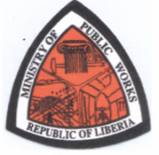
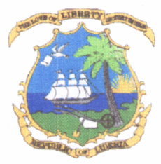
REPUBLIC OF LIBERIA
MINISTRY OF PUBLIC WORKS
P. O. BOX 9011
SOUTH, LYNCH STREET
MONROVIA, LIBERIA
November 9, 2021

PUBLIC SERVICE ANNOUNCEMENT

Subject: Submission of Ownership Documents for Claim of Resettlement Compensation for
Impacted Properties in the Right-of-Way along the ELWA Junction to Rock Church Community and the Unification City to Disco Hill Road Segments

All individuals whose properties are found within the right-of-way and marked with the unique “RIA” prefix along the ELWA Junction to Rock Church Community and Unification City to Disco Hill road segments, who have not submitted proof of ownership documents for compensation by the Ministry of Public Works are hereby encouraged to do so between November 9, 2021 to February 28, 2022. The Paynesville City, Unification City Corporations and the Office of the Township Commissioner for Duazon are currently validating ownership documents and providing attestations to legitimate owners of affected properties for onward submission to the Ministry of Public Works.

Kindly note that there will be no payment made to owners of unidentified affected properties after the stipulated deadline of February 28, 2022.

The support and cooperation of all concerned parties is highly appreciated.

For further information or clarification, please contact the Resettlement, Environmental and Social Safeguard and the Zoning Divisions of the Ministry of Public Works.

Signed: _______________________
Hon. Joseph P. Todd
Deputy Minister for Administration

